| **Test Name** | | | Launch Application | | | |
| --- | --- | --- | --- | --- | --- | --- |
| **Use Case Tested:** | | | Launching a game | | | |
| **Test Description:** | | | Verify that splash screen shows then changes into Login or Register choice panel | | | |
| **Pre-conditions** | | | Game must be installed | | | |
| **Post-conditions** | | | User is given a choice to Login or Register | | | |
| **Notes:** | |  | | | | |
| **Result (Pass/Fail/Warning/Incomplete)** | | **Pass** | | | | |
|  | **TEST STEP** | | | **EXPECTED TEST RESULTS** | P | F |
|  | Open game | | | Splash screen should display Let’s Quiz for a few seconds then navigate to Login/Register choice screen | P |  |

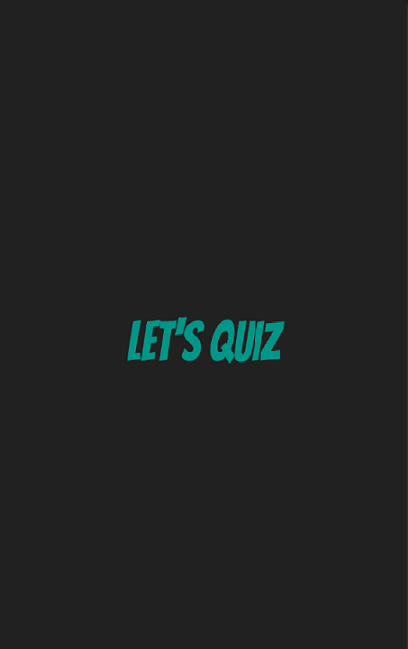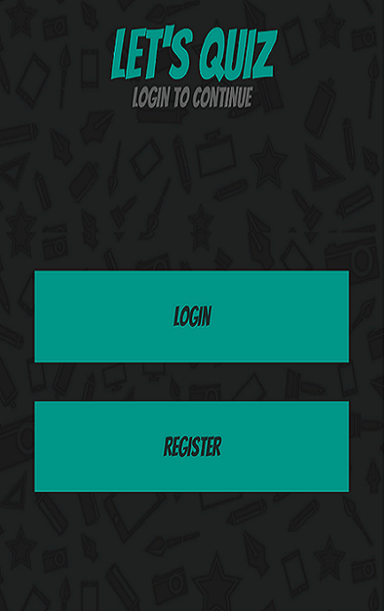

| **Test Name** | | | Launching a game | | | |
| --- | --- | --- | --- | --- | --- | --- |
| **Use Case Tested:** | | | Launching a game- Choose login or register | | | |
| **Test Description:** | | | Verify that login and register buttons work | | | |
| **Pre-conditions** | | | Login/Register panel should be open screen must be open | | | |
| **Post-conditions** | | | That the desired screen panel should be shown | | | |
| **Notes:** | |  | | | | |
| **Result (Pass/Fail/Warning/Incomplete)** | | **Pass** | | | | |
|  | **TEST STEP** | | | **EXPECTED TEST RESULTS** | P | F |
| 1 | Press login button | | | Login screen should be displayed | p |  |
|  | Press register button | | | Login screen should be displayed | P |  |

